Dashboard Screenshots, Story Screenshots & Tableau Public Links
Project: India's Agricultural Crop Production Analysis using Tableau | Submission Date: 13 July 2026 | SmartBridge Internship

SECTION 1: PROJECT OVERVIEW
This technical report outlines the visual architecture and comprehensive analysis framework developed for the project titled "India's Agricultural Crop Production Analysis using Tableau." The primary objective of this project is to systematically analyze and convert the raw insights buried within India's Agricultural Crop Production Dataset (spanning the years 1997 to 2021) into an intuitive, accessible, and interactive ecosystem using Tableau Public. Agriculture remains a critical cornerstone of the Indian economy, yet stakeholders frequently struggle to extract actionable policy options from high-volume historical datasets.
By leveraging Tableau Public's powerful analytical engine, this project establishes a series of sophisticated, interactive dashboards and structured data stories that decipher complex patterns in cultivation. The resulting visual models are tailored to facilitate data-driven agricultural decision-making for farmers, agronomists, educational researchers, and public policymakers. Through multi-dimensional field assessments, dynamic geographical mapping, and yield computations, this business intelligence tool handles complex transformations effortlessly, presenting critical historical trends and production distributions across diverse Indian states, crop variations, and seasonal cycles in a single unified view.

SECTION 2: TABLEAU DASHBOARD SCREENSHOTS
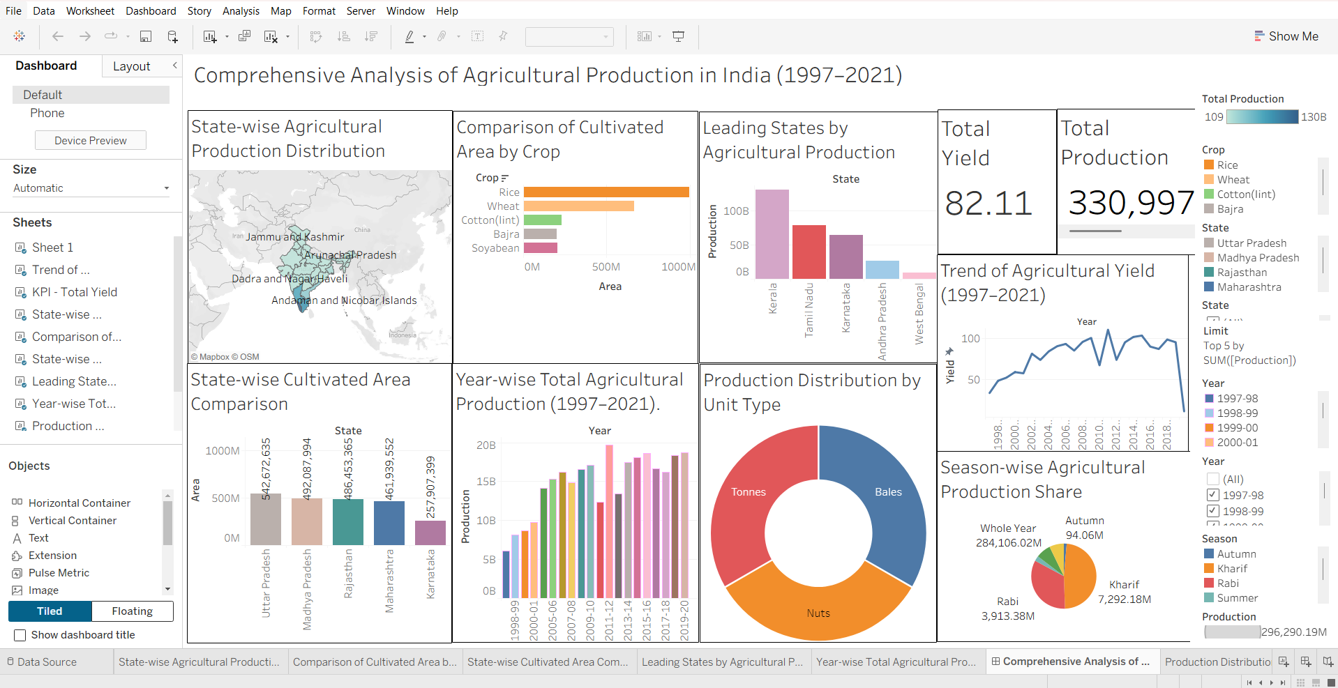
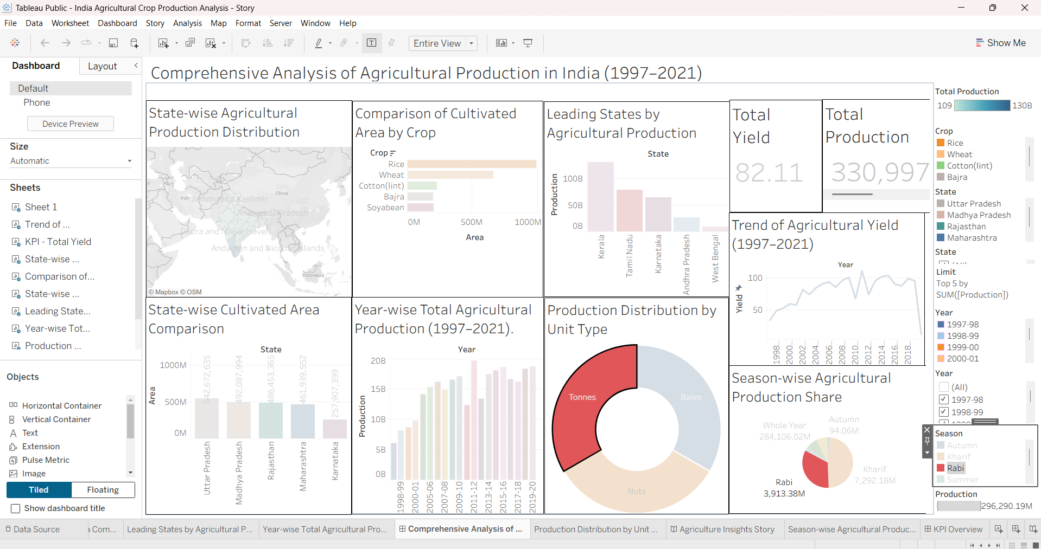
The integrated Tableau Dashboard functions as a central diagnostic console designed for comprehensive exploration. It incorporates precise KPI Cards displaying critical aggregations including Total Production volume, Average Yield performance, and the cumulative Total Area under cultivation. Geographical distributions are visualized through a high-fidelity State-wise Production Map, allowing users to rapidly isolate high-performing territories. The interface facilitates robust Crop Comparison models and tracks complex Year-wise Trends to reveal overarching trajectory patterns.
Furthermore, dedicated widgets manage Season Analysis and Yield Analysis to evaluate core agricultural productivity metrics. Guided by highly responsive Interactive Filters for state, crop, year, and season, users can isolate custom sub-segments instantly. The combination of these visual elements empowers stakeholders to diagnose macro-level historical dependencies and micro-level cultivation fluctuations across the country seamlessly.

SECTION 3: DASHBOARD COMPONENTS
Component | Description
KPI Cards | Display Total Production, Average Yield and Total Area fields clearly at a macro level.
State Map | Visualizes regional agricultural production across Indian states with precise thematic shading.
Crop Comparison | Enables direct side-by-side benchmarking of individual crop production volumes.
Year Trend | Illustrates annual production trajectories over time to reveal multi-year cycles.
Season Analysis | Examines seasonal variations and isolates output variations across distinct cultivation timelines.
Yield Analysis | Delivers deep productivity comparisons by evaluating output ratios against land area.
Interactive Filters | Allows dynamic scoping by State, Crop, Year, and Season categories simultaneously.
Dashboard Actions | Implements cross-filtering and interactive navigation triggers across all charts upon selection.

SECTION 4: TABLEAU STORY SCREENSHOTS
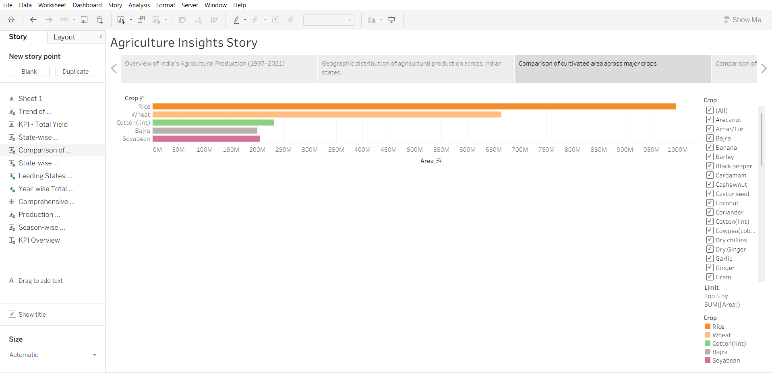
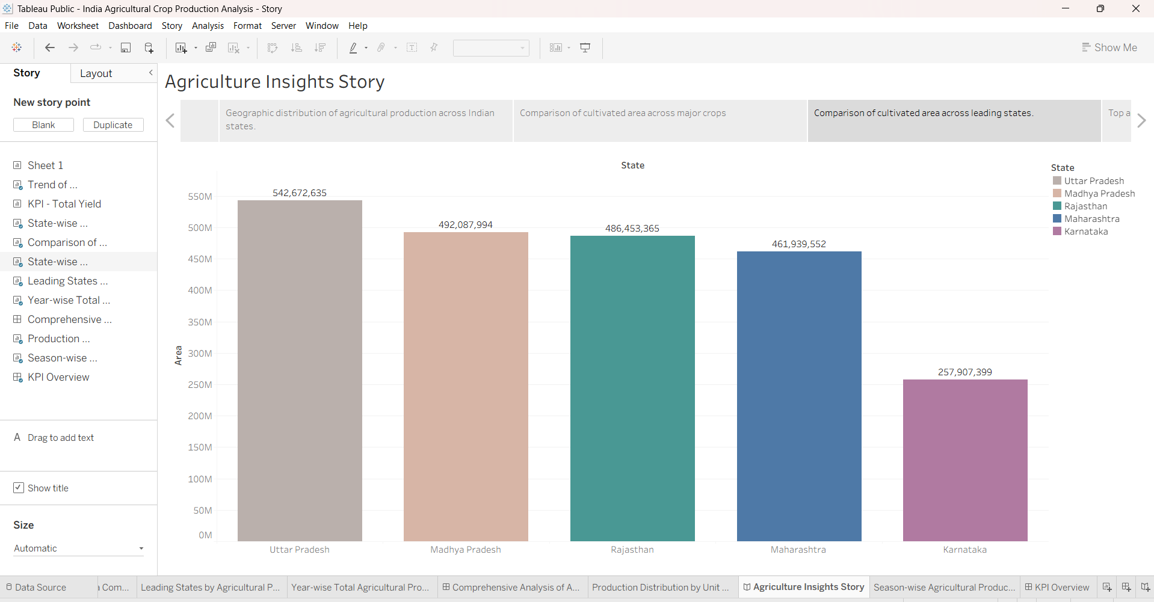
The Tableau Story framework provides a highly structured narrative pathway that guides users sequentially through complex analytical findings rather than overwhelming them with raw data. It translates the multidimensional dataset into an intuitive narrative arc that addresses specific operational queries at each step. By organizing the dashboards into distinct, logical story points, the presentation flows systematically from high-level, nationwide production overviews down to hyper-localized regional and crop-specific insights. Each phase within this analytical sequence pairs robust interactive charts with contextual commentary, enabling users to trace the underlying causes of historical anomalies, identify crop shifts, and observe yield variations. This narrative sequence ensures that final insights emerge clearly, laying a solid foundation for informed strategic planning.

SECTION 5: STORY POINTS
Story Point | Label | Description
Story Point 1 | Project Overview | Introduces scope, objective, and macro baseline details of the dataset.
Story Point 2 | State-wise Analysis | Examines distribution patterns and identifies key production zones.
Story Point 3 | Crop Comparison | Compares production yields across grain, cash crop, and oilseed sectors.
Story Point 4 | Season Analysis | Breaks down outputs across Kharif, Rabi, Zaid, and Whole Year periods.
Story Point 5 | Yield Analysis | Identifies efficiency metrics by highlighting optimal land utilization.
Story Point 6 | Final Insights | Synthesizes data findings into actionable policy recommendations.

SECTION 6: TABLEAU PUBLIC LINKS
Resource |  | Link URL Placeholder
Dashboard Link | https://public.tableau.com/app/profile/chinmaya.sai.nagella/viz/IndiaAgriculturalCropProductionAnalysis-Story/AgricultureInsightsStory
Story Link | https://public.tableau.com/app/profile/chinmaya.sai.nagella/viz/IndiaAgriculturalCropProductionAnalysis-Story/AgricultureInsightsStory
GitHub Repository | https://github.com/nagellachinmayasai-code/Agricultural-Crop-Production-Analysis-Tableau

SECTION 7: KEY INSIGHTS
- Kerala demonstrates high agricultural production: Data tracking identifies the region as a significant driver of overall yield metrics due to optimal environmental factors.
- Rice contributes significantly to total production: Longitudinal trends confirm rice as a dominant staple food crop, representing a massive share of the aggregate volume.
- Production varies across different years: Significant macro fluctuations occur between 1997 and 2021, suggesting structural adjustments and shifting climatic patterns.
- Seasonal analysis highlights cultivation trends: The visual outputs establish strong seasonal preferences, defining clear boundaries between crop types across cycles.
- Yield analysis compares productivity across states: Normalizing the output volume against land area highlights efficient farming hubs independent of gross state sizes.
- Interactive filters improve exploration: The inclusion of live sorting mechanisms enables direct ad-hoc testing, increasing data transparency.
- Tableau Dashboard and Story together support data-driven agricultural decisions: Combining exploration with narrative structures bridges the gap between historical metrics and current policy execution.

SECTION 8: CONCLUSION
In conclusion, this analytical project successfully demonstrates how the Tableau Dashboard and Story frameworks can effectively transform large volumes of raw agricultural data into highly structured, meaningful visual insights. By taking historical data from 1997 to 2021 and applying structured visual rules, the application eliminates static interpretation bottlenecks, turning hidden trends into obvious, addressable patterns. This centralized intelligence setup provides a highly functional platform where farmers can understand historical seasonal crop returns, researchers can dissect output correlations, students can trace regional agro-economic profiles, and policymakers can evaluate the effectiveness of historic land-use allocations.
The interactive structure ensures that data remains accessible and engaging, encouraging users to discover unique regional insights. Ultimately, this system establishes a reliable, data-driven approach to understanding agricultural dynamics, proving that purposeful business intelligence tools are essential for securing sustainable development, mitigating ecological uncertainty, and optimizing food supply logistics across India.

